LAPORAN PRAKTIKUM ALGORITMA DAN STRUKTUR DATA
PRAKTIKUM 2


Dzakiy Ibnu Khoir (5225600061)
PROGRAM STUDI SARJANA TERAPAN TEKNOLOGI GAME
JURUSAN TEKNOLGOI MULTEMDIA KREATIF
POLITEKNIK ELEKTRONIKA NEGERI SURABAYA
2026

Latihan 1
- Code
#include <iostream>
using namespace std;

struct Node {
int data;
Node* next;
};

int main() {
Node* node1 = new Node;
Node* node2 = new Node;
Node* node3 = new Node;

node1->data = 10;
node2->data = 20;
node3->data = 30;

node1->next = node2;
node2->next = node3;
node3->next = nullptr;

Node* temp = node1;
while (temp != nullptr){
cout << temp->data << " -> ";
temp = temp->next;
}
cout << "Null\n";

}

- Output
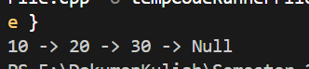
- Penjelasan
Program tersebut membuat tiga node secara dinamis, menghubungkannya menjadi sebuah singly linked list berisi 10 → 20 → 30, lalu melakukan traversal untuk menampilkan seluruh isi list hingga mencapai nullptr.
- Visualisasi
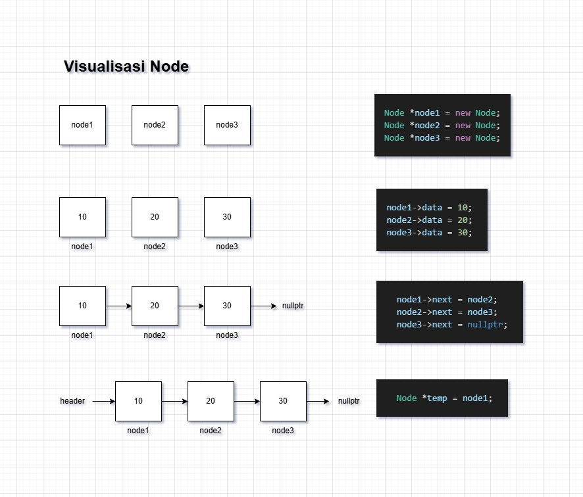
Latihan 2
- Code
#include <iostream>
using namespace std;

struct Node
{
int data;
Node *next;
};

Node *head = nullptr;

void insertFront(int value)
{
Node *newNode = new Node;
newNode->data = value;
newNode->next = head;
head = newNode;
}

int main()
{
Node *node1 = new Node{50, nullptr};
Node *node2 = new Node{60, nullptr};
Node *node3 = new Node{70, nullptr};

head = node1;

node1->next = node2;
node2->next = node3;
node3->next = nullptr;

insertFront(30);
insertFront(20);
insertFront(10);

Node *temp = head;
while (temp != nullptr)
{
cout << temp->data << " -> ";
temp = temp->next;
}
cout << "Null\n";
}

- Output
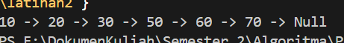
- Penjlasan
Program tersebut membuat linked list awal berisi 50 → 60 → 70, lalu menambahkan tiga node baru (10, 20, 30) di bagian depan menggunakan fungsi insertFront, sehingga akhirnya menjadi 10 → 20 → 30 → 50 → 60 → 70, kemudian menampilkan seluruh isi list hingga nullptr
- Visualisasi
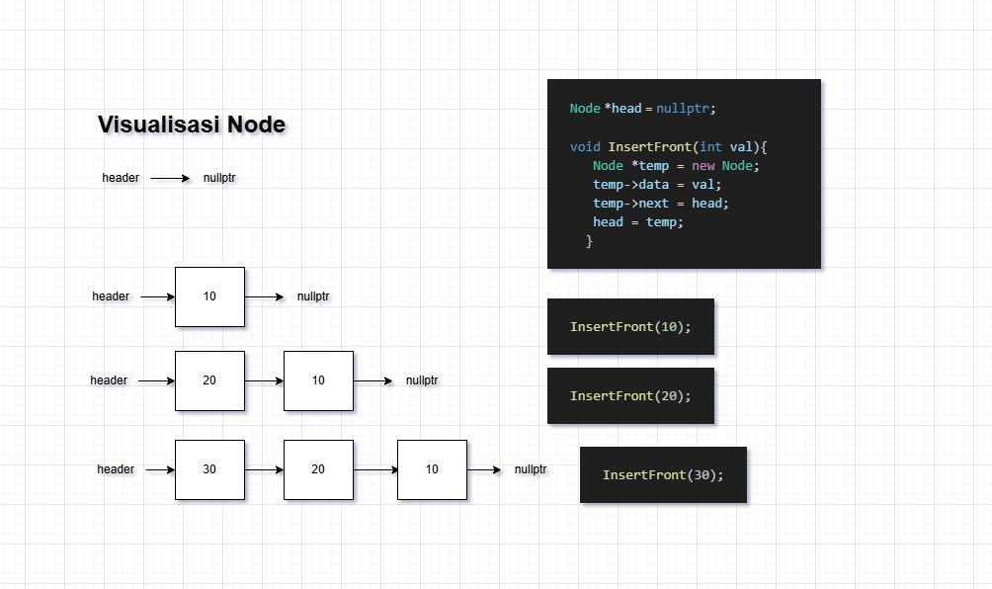

Latihan 3
- Code
#include <iostream>
using namespace std;

struct Node
{
int data;
Node *next;
};

Node *head = nullptr;

void insertBack(int value)
{
Node *newNode = new Node;
newNode->data = value;
newNode->next = nullptr;
if (head == nullptr)
{
head = newNode;
return;
}
Node *temp = head;
while (temp->next != nullptr)
temp = temp->next;
temp->next = newNode;
}

void insertFront(int value)
{
Node *newNode = new Node;
newNode->data = value;
newNode->next = head;
head = newNode;
}

int main()
{
Node *node1 = new Node{50, nullptr};
Node *node2 = new Node{60, nullptr};
Node *node3 = new Node{70, nullptr};

head = node1;

node1->next = node2;
node2->next = node3;
node3->next = nullptr;

insertFront(30);
insertFront(20);
insertFront(10);

insertBack(80);

Node *temp = head;
while (temp != nullptr)
{
cout << temp->data << " -> ";
temp = temp->next;
}
cout << "Null\n";
}

- Output
- Penjelasan
Program tersebut membuat linked list awal 50 → 60 → 70, kemudian menambahkan 10, 20, dan 30 di bagian depan serta 80 di bagian belakang menggunakan fungsi insertFront dan insertBack, sehingga hasil akhirnya menjadi 10 → 20 → 30 → 50 → 60 → 70 → 80, lalu menampilkan seluruh isi list hingga nullptr
Latihan 4
- Code
#include <iostream>
using namespace std;

struct Node
{
int data;
Node *next;
};

Node *head = nullptr;

void insertBack(int value)
{
Node *newNode = new Node;
newNode->data = value;
newNode->next = nullptr;
if (head == nullptr)
{
head = newNode;
return;
}
Node *temp = head;
while (temp->next != nullptr)
temp = temp->next;
temp->next = newNode;
}

void insertFront(int value)
{
Node *newNode = new Node;
newNode->data = value;
newNode->next = head;
head = newNode;
}

void insertAfter(int key, int value)
{
Node *temp = head;
while (temp != nullptr && temp->data != key)
temp = temp->next;
if (temp == nullptr)
return;
Node *newNode = new Node;
newNode->data = value;
newNode->next = temp->next;
temp->next = newNode;
}
void insertBefore(int key, int value)
{
if (head == nullptr)
return;
if (head->data == key)
{
insertFront(value);
return;
}
Node *prev = nullptr;
Node *curr = head;
while (curr != nullptr && curr->data != key)
{
prev = curr;
curr = curr->next;
}
if (curr == nullptr)
return;
Node *newNode = new Node;
newNode->data = value;
prev->next = newNode;
newNode->next = curr;
}

int main()
{
Node *node1 = new Node{50, nullptr};
Node *node2 = new Node{60, nullptr};
Node *node3 = new Node{70, nullptr};

head = node1;

node1->next = node2;
node2->next = node3;

insertFront(30);
insertFront(20);
insertFront(10);

insertBack(80);
insertAfter(30, 40);
insertBefore(60, 55);

Node *temp = head;
while (temp != nullptr)
{
cout << temp->data << " -> ";
temp = temp->next;
}
cout << "Null\n";
}

- Output
- Penjelasan
Program tersebut membuat linked list awal 50 → 60 → 70, lalu menambahkan 10, 20, dan 30 di depan, 80 di belakang, menyisipkan 40 setelah 30 serta 55 sebelum 60 menggunakan berbagai fungsi insert, sehingga hasil akhirnya menjadi 10 → 20 → 30 → 40 → 50 → 55 → 60 → 70 → 80, kemudian menampilkan seluruh isi list hingga nullptr
Latihan 5
- Code
#include <iostream>
using namespace std;

struct Node
{
int data;
Node *next;
};

Node *head = nullptr;

void insertBack(int value)
{
Node *newNode = new Node;
newNode->data = value;
newNode->next = nullptr;
if (head == nullptr)
{
head = newNode;
return;
}
Node *temp = head;
while (temp->next != nullptr)
temp = temp->next;
temp->next = newNode;
}

void insertFront(int value)
{
Node *newNode = new Node;
newNode->data = value;
newNode->next = head;
head = newNode;
}

void insertAfter(int key, int value)
{
Node *temp = head;
while (temp != nullptr && temp->data != key)
temp = temp->next;
if (temp == nullptr)
return;
Node *newNode = new Node;
newNode->data = value;
newNode->next = temp->next;
temp->next = newNode;
}
void insertBefore(int key, int value)
{
if (head == nullptr)
return;
if (head->data == key)
{
insertFront(value);
return;
}
Node *prev = nullptr;
Node *curr = head;
while (curr != nullptr && curr->data != key)
{
prev = curr;
curr = curr->next;
}
if (curr == nullptr)
return;
Node *newNode = new Node;
newNode->data = value;
prev->next = newNode;
newNode->next = curr;
}

void deleteByValue(int key)
{
if (head == nullptr)
{
cout << "List kosong.\n";
return;
}
// Jika head adalah key
if (head->data == key)
{
Node *temp = head;
head = head->next;
delete temp;
cout << "Node dengan nilai " << key << " dihapus.\n";
return;
}
Node *prev = head;
Node *curr = head->next;
while (curr != nullptr && curr->data != key)
{
prev = curr;
curr = curr->next;
}
if (curr == nullptr)
{
cout << "Nilai tidak ditemukan.\n";
return;
}
prev->next = curr->next;
delete curr;
cout << "Node dengan nilai " << key << " dihapus.\n";
}

int main()
{
Node *node1 = new Node{50, nullptr};
Node *node2 = new Node{60, nullptr};
Node *node3 = new Node{70, nullptr};

head = node1;

node1->next = node2;
node2->next = node3;
node3->next = nullptr;

insertFront(30);
insertFront(20);
insertFront(10);

insertBack(80);
insertAfter(30, 40);
insertBefore(60, 55);
deleteByValue(80);

Node *temp = head;
while (temp != nullptr)
{
cout << temp->data << " -> ";
temp = temp->next;
}

cout << "Null\n";
}

- Output
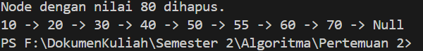
- Penjelasan
Program tersebut membuat linked list awal 50 → 60 → 70, kemudian menambahkan beberapa node di depan, belakang, sebelum, dan sesudah nilai tertentu, lalu menghapus node bernilai 80 menggunakan deleteByValue, sehingga hasil akhirnya menjadi 10 → 20 → 30 → 40 → 50 → 55 → 60 → 70, dan akhirnya menampilkan seluruh isi list hingga nullptr
Tugas
- Code
#include <iostream>

using namespace std;

struct EnemyData
{
string enemy_name;
int enemy_health;
int enemy_attack;
};

struct Node
{
EnemyData data;
Node *next;
};

Node *head = nullptr;

int countEnemies()
{
int count = 0;
Node *temp = head;

while (temp != nullptr)
{
count++;
temp = temp->next;
}
return count;
}

void printList()
{
Node *temp = head;
while (temp != nullptr)
{
cout << temp->data.enemy_name << " (HP:"
<< temp->data.enemy_health << ", ATK:"
<< temp->data.enemy_attack << ") -> ";
temp = temp->next;
}
cout << "Null\n";
}

void insertBack(const EnemyData &value)
{
Node *newNode = new Node;
newNode->data = value;
newNode->next = nullptr;

if (head == nullptr)
{
head = newNode;
return;
}

Node *temp = head;
while (temp->next != nullptr)
temp = temp->next;

temp->next = newNode;
}

void insertFront(const EnemyData &value)
{
Node *newNode = new Node;
newNode->data = value;
newNode->next = head;
head = newNode;
}

void insertAfter(const string &key, const EnemyData &value)
{
Node *temp = head;

while (temp != nullptr && temp->data.enemy_name != key)
temp = temp->next;

if (temp == nullptr)
return;

Node *newNode = new Node;
newNode->data = value;
newNode->next = temp->next;
temp->next = newNode;
}

void insertBefore(const string &key, const EnemyData &value)
{
if (head == nullptr)
return;

if (head->data.enemy_name == key)
{
insertFront(value);
return;
}

Node *prev = nullptr;
Node *curr = head;

while (curr != nullptr && curr->data.enemy_name != key)
{
prev = curr;
curr = curr->next;
}

if (curr == nullptr)
return;

Node *newNode = new Node;
newNode->data = value;
newNode->next = curr;
prev->next = newNode;
}

void deleteByName(const string &key)
{
if (head == nullptr)
{
cout << "List kosong.\n";
return;
}

if (head->data.enemy_name == key)
{
Node *temp = head;
head = head->next;
delete temp;
cout << "Enemy " << key << " dihapus.\n";
return;
}

Node *prev = head;
Node *curr = head->next;

while (curr != nullptr && curr->data.enemy_name != key)
{
prev = curr;
curr = curr->next;
}

if (curr == nullptr)
{
cout << "Enemy tidak ditemukan.\n";
return;
}

prev->next = curr->next;
delete curr;
cout << "Enemy " << key << " dihapus.\n";
}

int main()
{
int choice;

while (true)
{
cout << "\n===== Enemy Manager =====\n";
cout << "1. Spawn Enemy (Insert Back)\n";
cout << "2. Insert Enemy BEFORE target (by name)\n";
cout << "3. Kill Enemy (Delete by Name)\n";
cout << "4. Show Enemy list\n";
cout << "5. Count Enemies\n";
cout << "0. Exit\n";
cout << "Pilih: ";
cin >> choice;

cin.ignore();

switch (choice)
{
case 1:
{
cout << "======== Spawn Enemy ========\n";

EnemyData e;
cout << "Enemy Name: ";
getline(cin, e.enemy_name);

cout << "Enemy Health: ";
cin >> e.enemy_health;

cout << "Enemy Attack: ";
cin >> e.enemy_attack;
cin.ignore();

insertBack(e);
break;
}

case 2:
{
cout << "======== Insert BEFORE ========\n";

string key;
cout << "Insert before enemy name: ";
getline(cin, key);

EnemyData e;
cout << "New Enemy Name: ";
getline(cin, e.enemy_name);

cout << "Enemy Health: ";
cin >> e.enemy_health;

cout << "Enemy Attack: ";
cin >> e.enemy_attack;
cin.ignore();

insertBefore(key, e);
break;
}

case 3:
{
cout << "======== Kill Enemy ========\n";
cout << "List Enemy yang ada" << endl;
printList();
string key;
cout << "Enemy name to delete: ";
getline(cin, key);

deleteByName(key);
break;
}

case 4:
printList();
break;

case 5:
cout << "Total Enemies: " << countEnemies() << endl;
break;

case 0:
cout << "Keluar...\n";
return 0;

default:
cout << "Pilihan tidak valid\n";
}
}
}

- Output
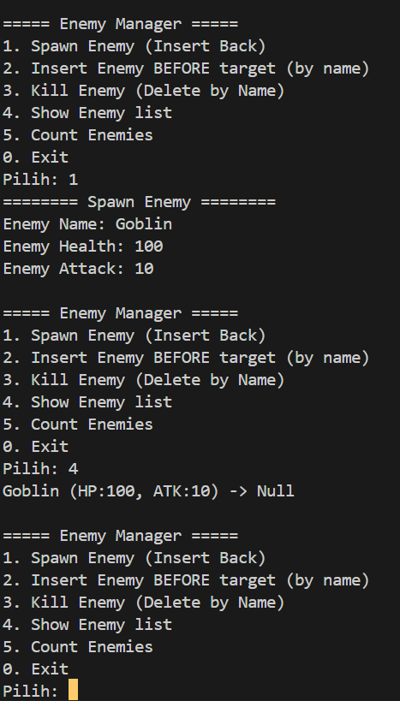

- Penjelasan
Program tersebut membuat sistem game sederhana berbasis linked list untuk mengelola musuh, di mana pemain dapat men-spawn enemy (tambah di belakang), menyisipkan enemy sebelum target tertentu (misalnya boss), menghapus enemy yang mati berdasarkan nama, menampilkan semua enemy aktif, serta menghitung total enemy

